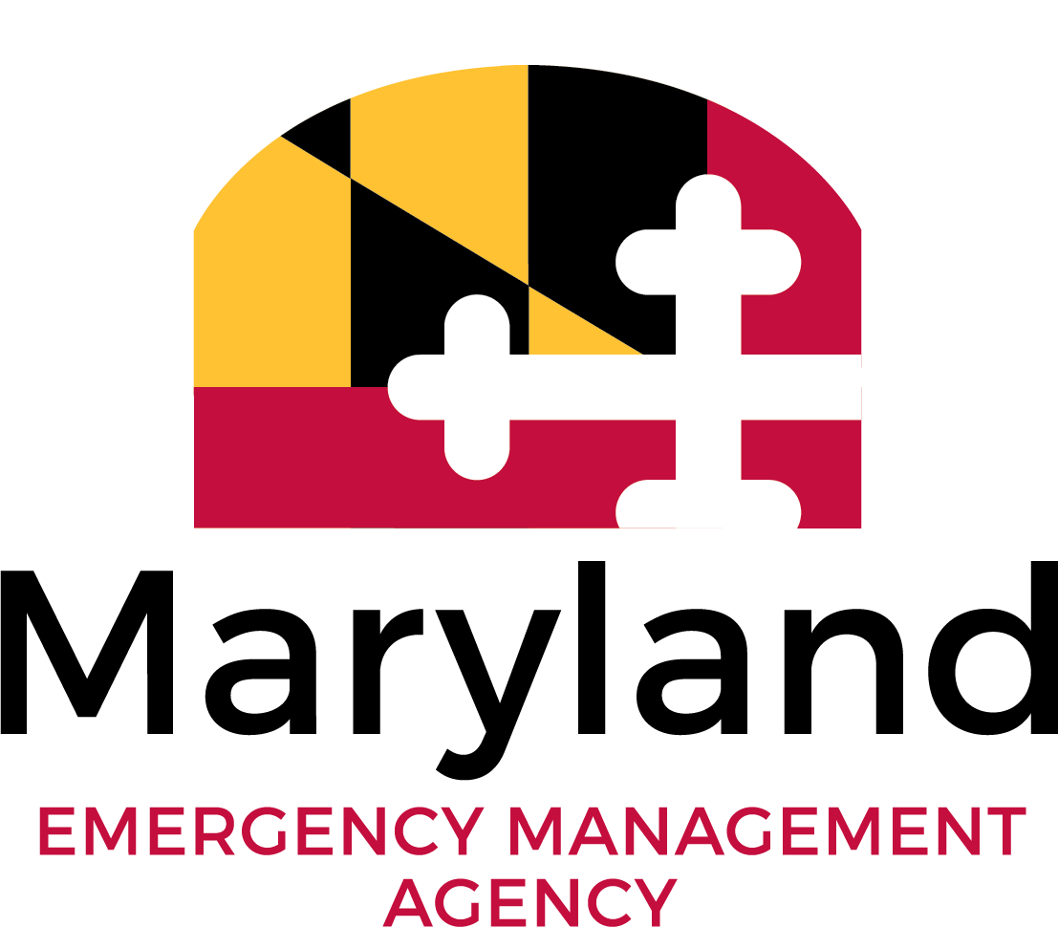
MEMA NOTICE OF INTEREST (NOI)
Hazard Mitigation Assistance (HMA) Grant Programs
Submit to mitigation.mema@maryland.gov
1.0 PROGRAM PREFERENCE
Please check the program you are most interested in pursuing:
☐Hazard Mitigation Grant Program (HMGP) - post-disaster declaration.
☐Building Resilient Infrastructure and Communities (BRIC) - annual grants.
☐Flood Mitigation Assistance (FMA) - annual grants for activities addressing flooding. Structures must be insured under the National Flood Insurance Program (NFIP).
☐ Unsure/Other
2.0 SUBAPPLICANT IDENTIFICATION
Name of Project
Subapplicant
Point of Contact
3.0 COMMUNITY IDENTIFICATION
Describe project relationship to local and state mitigation strategies.
Location
Relationship to Existing Community Plans
Mitigation Plan Expiration
Community in Good Standing with NFIP
Impact on People
Impact on Environment
4.0 ACTIVITY
Description of Project or Plan
Estimated Project Schedule
5.0 COST ESTIMATE
Total Activity Cost
Proposed Non-federal Cost Share and Source

